 |  |  |  |  |  | 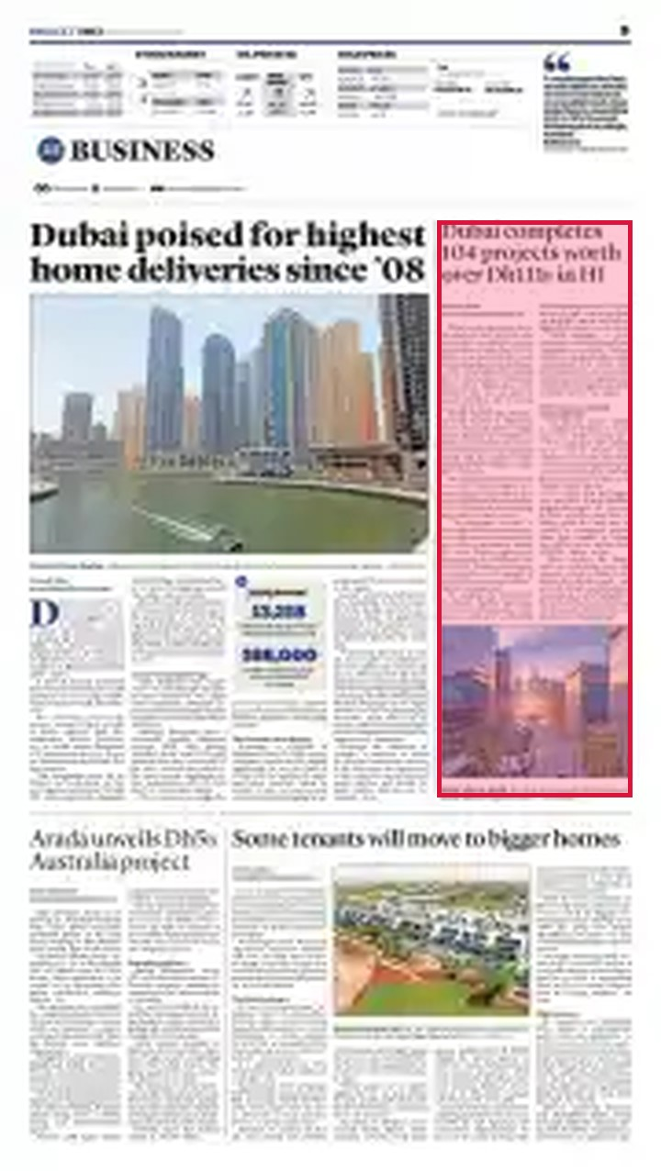
 | Publication | Khaleej Times | Circulation | 89827
 | Market | United Arab Emirates | Page No. | 9
 | Section | Business | Size | 51 cc

August 21, 2026
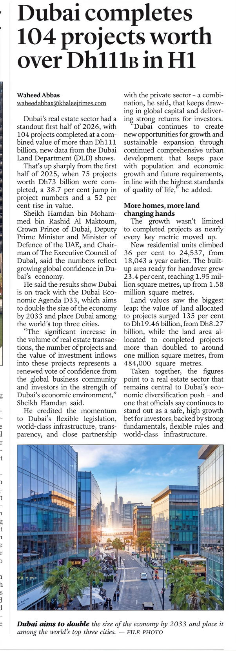

 |  |  |  |  |  | 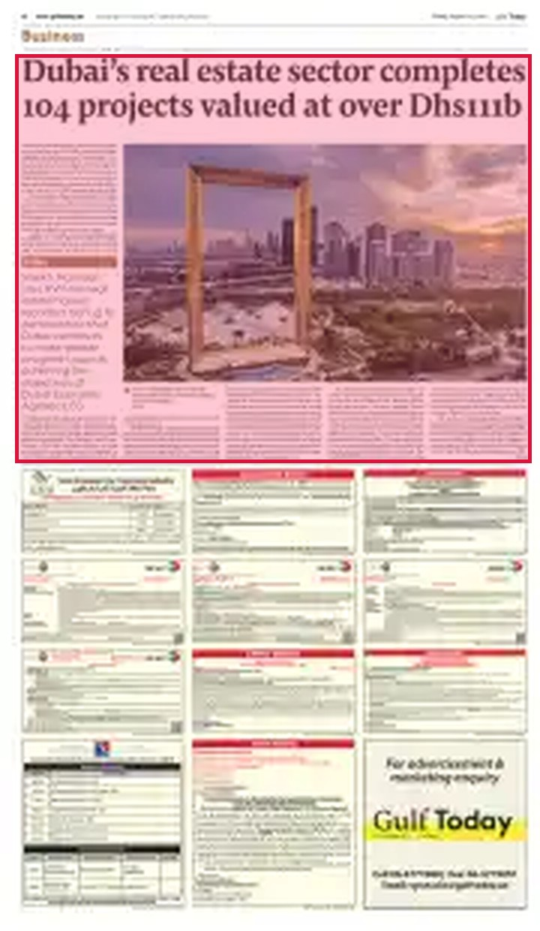
 | Publication | Gulf Today | Circulation | —
 | Market | United Arab Emirates | Page No. | 11
 | Section | Business | Size | 137 cc

August 21, 2026
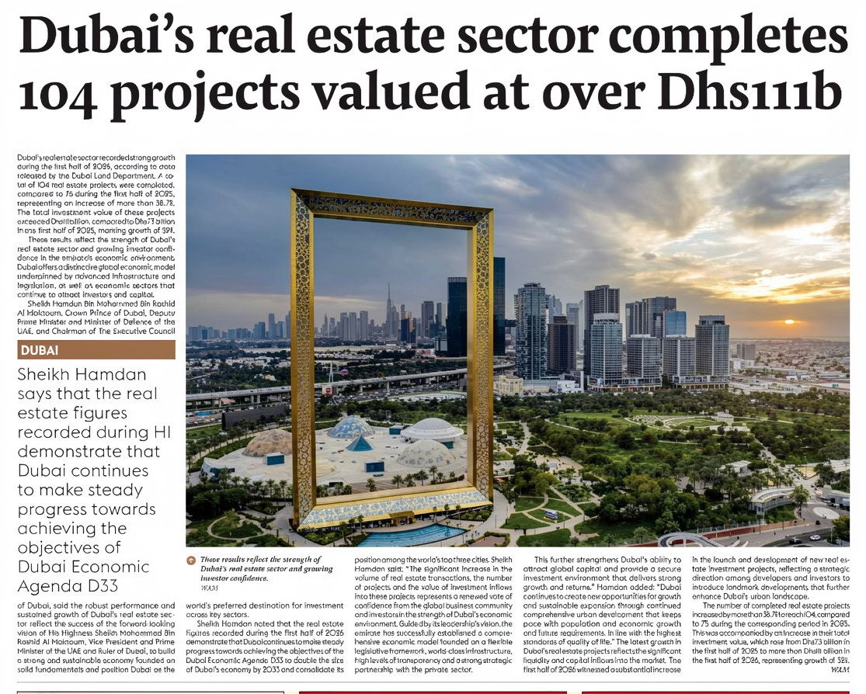

 |  |  |  |  |  | 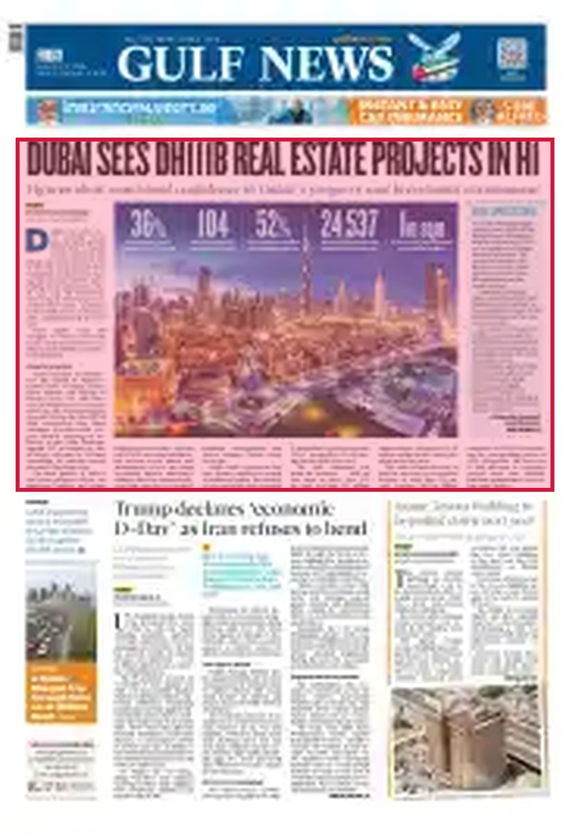
 | Publication | Gulf News | Circulation | 117000
 | Market | United Arab Emirates | Page No. | 1
 | Section | Front Page | Size | 132 cc

August 21, 2026
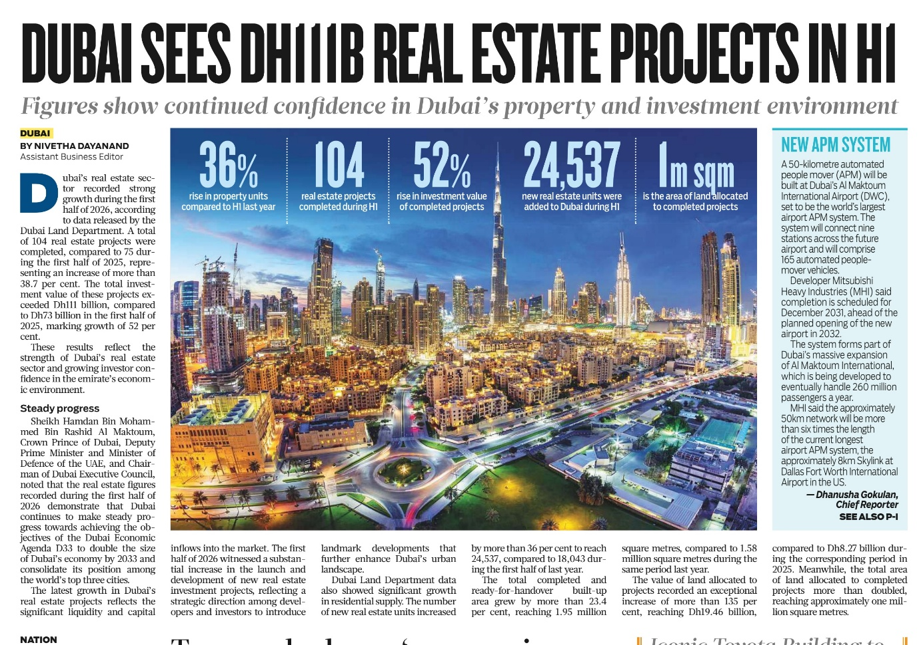

 |  |  |  |  |  | 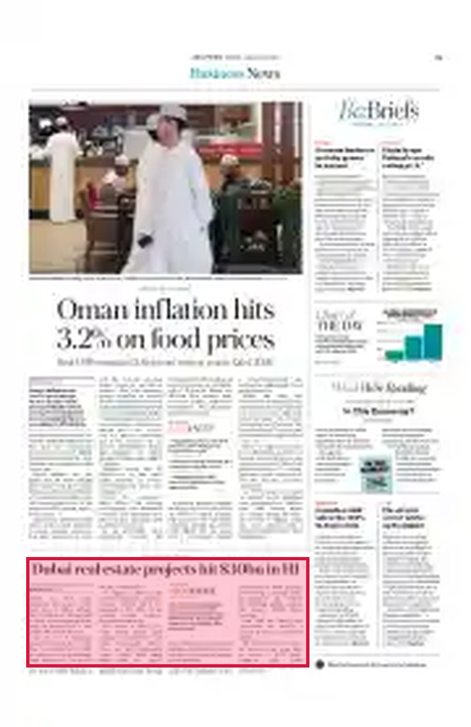
 | Publication | Arab News | Circulation | 51481
 | Market | Saudi Arabia | Page No. | 13
 | Section | Business News | Size | 31 cc

August 24, 2026
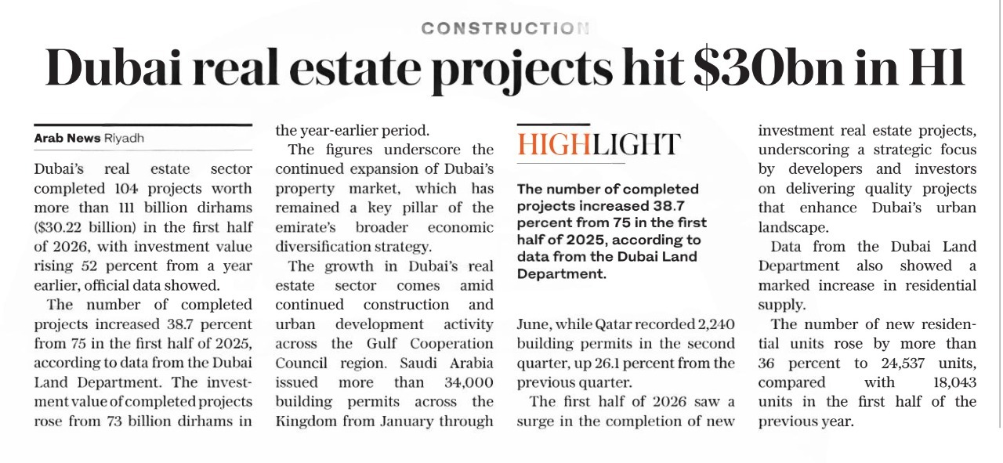

 |  |  |  |  |  | 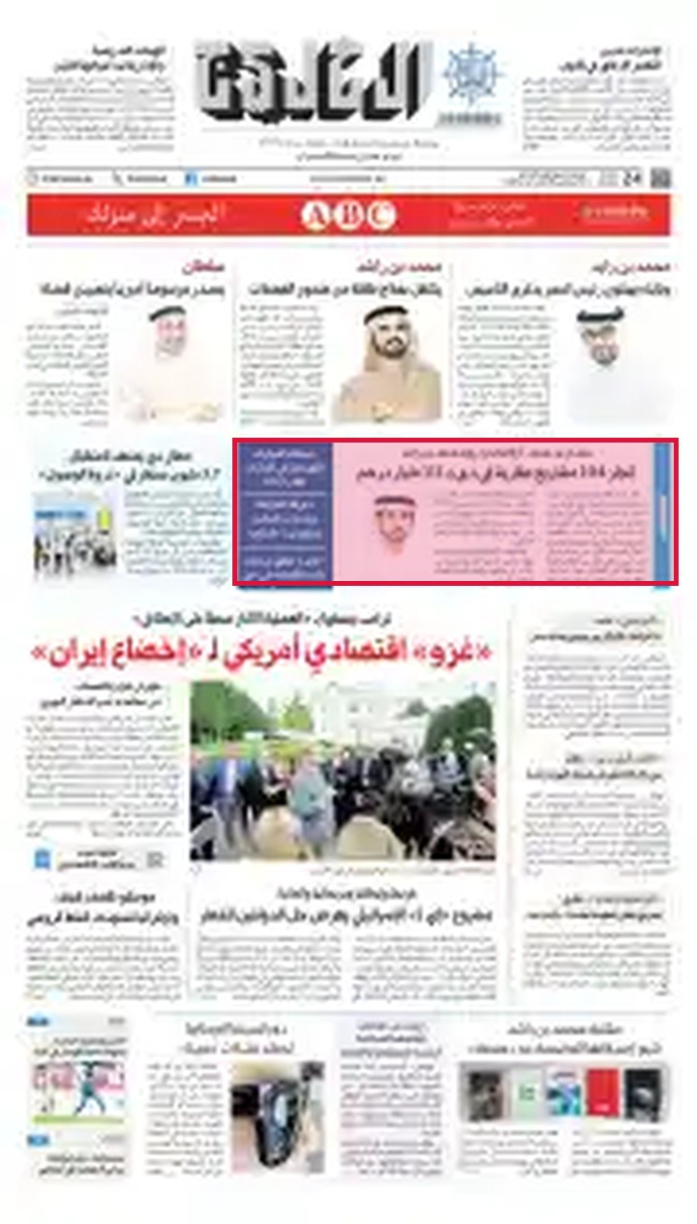
 | Publication | Al Khaleej | Circulation | 106266
 | Market | United Arab Emirates | Page No. | 1
 | Section | Front Page | Size | 31 cc

August 21, 2026
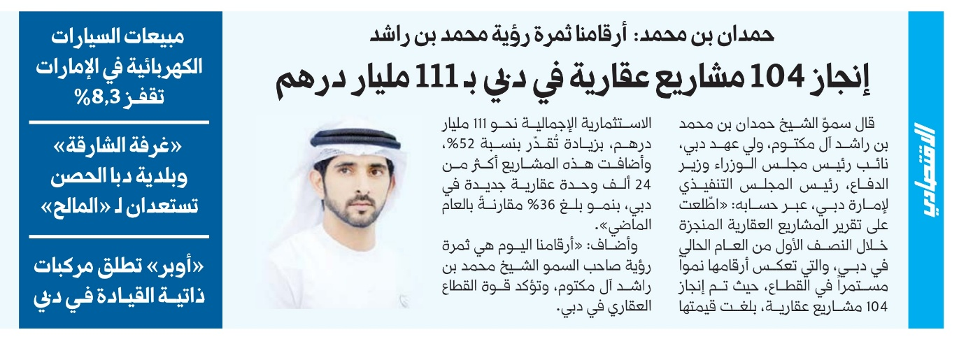

 |  |  |  |  |  | 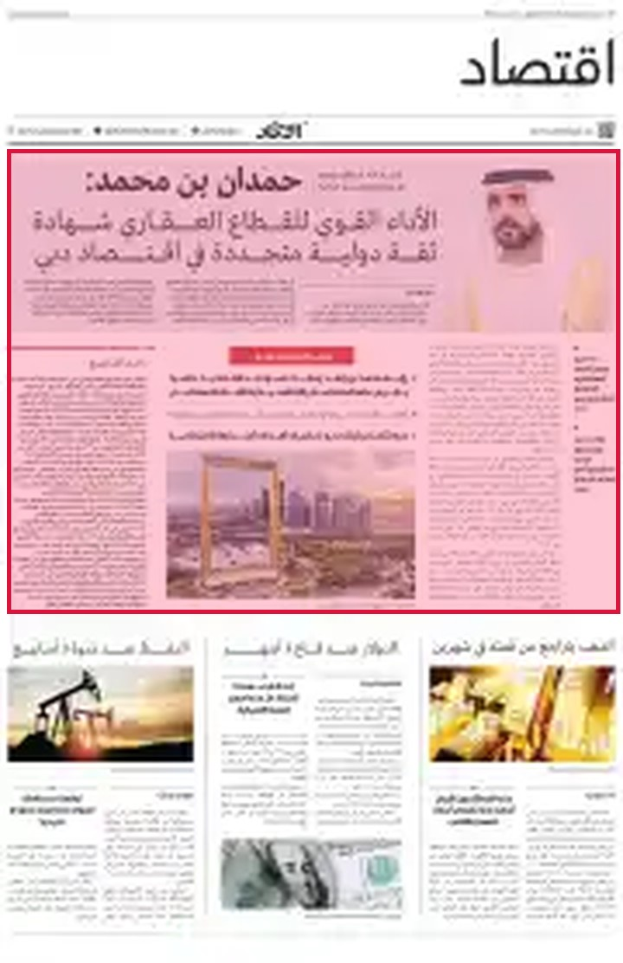
 | Publication | Al Ittihad | Circulation | 109640
 | Market | United Arab Emirates | Page No. | 12
 | Section | Economy | Size | 201 cc

August 21, 2026
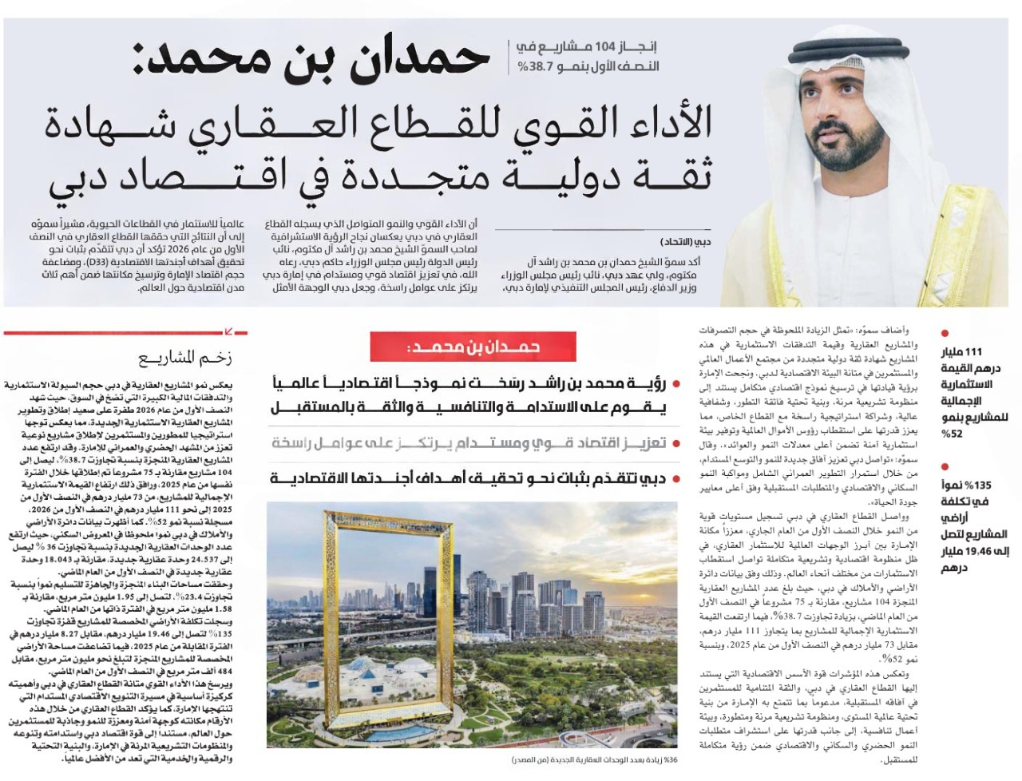

 |  |  |  |  |  | 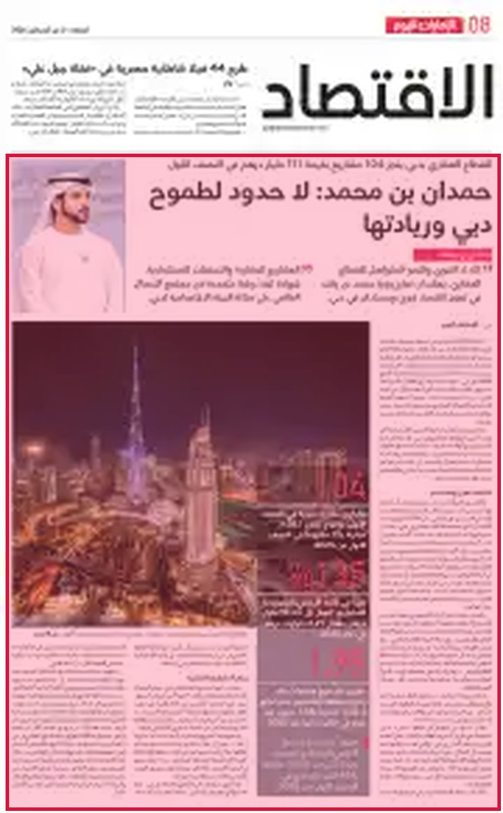
 | Publication | Emarat Al Youm | Circulation | 80000
 | Market | United Arab Emirates | Page No. | 8
 | Section | Economy | Size | 336 cc

August 21, 2026
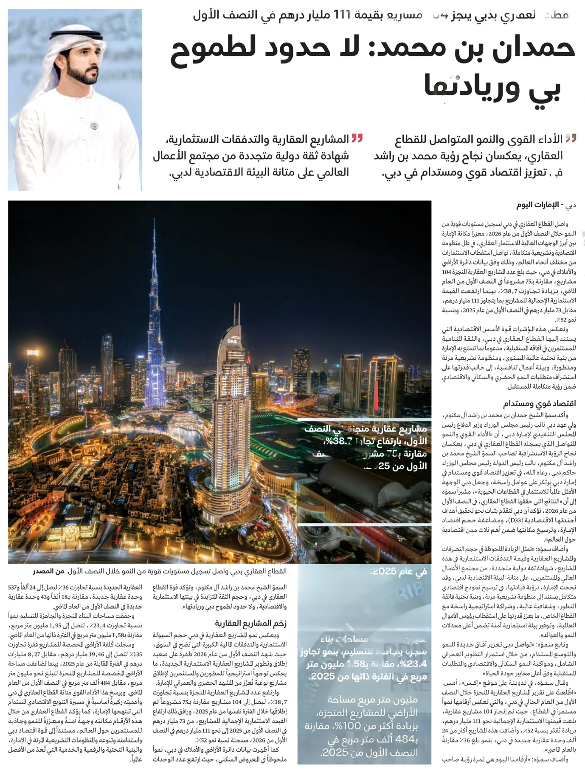

 |  |  |  |  |  | 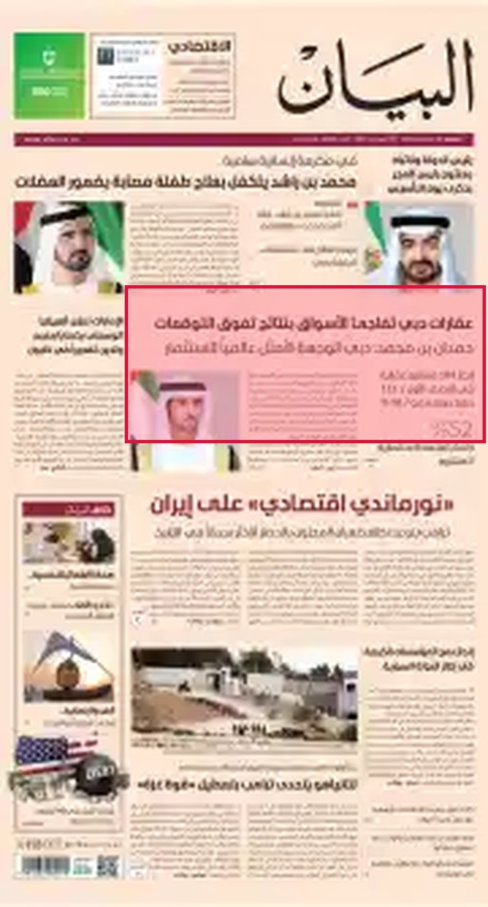
 | Publication | Al Bayan | Circulation | 88800
 | Market | United Arab Emirates | Page No. | 1
 | Section | Front Page | Size | 54 cc

August 21, 2026
